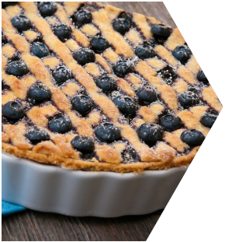
The Blueberry Pie

On April 10, 2014, my father passed away leaving my mother, Lucy, a widow living alone in the house she had owned with my dad for over 40 years. With no immediate family nearby, Mom lived alone for a little over a year following my dad's death before deciding that she needed to make a change. She relented to consider relocating to Louisville to be closer to me and my family and agreed that, as she was not comfortable with the idea of moving in with my wife and me, she should consider a senior living setting for her next home.

My mother, my out-of-town sister, and I immediately began making plans to visit 11 communities in Louisville over a period of almost 3 months. All three of us visited all 11 communities and out of these 11, only three followed up with us at all- one being the evening of the visit simply asking if I "had made a decision yet?" My response was a "no" and nothing more was heard from this community. The second community that followed up did so every Thursday at exactly 3:30pm with the sales director basically "checking in" and asking if I "had any questions or had made a decision yet?" The third community did a great job in creative follow up- more to come on that.

Of the 11 communities, three of them had no one at the front desk at all when we arrived and my family ended up self-touring without a single person stopping us or asking if they could help us. Two of these three communities even had the price sheets and brochure available on the front desk as if self-touring was expected, perhaps even encouraged. Obviously, we quickly eliminated these three communities as viable options due to safety concerns.

Being in the industry, I had done extensive research on local communities and had already landed on a favorite. Not only was the location perfect for my mom and me, the community had a great reputation and was affordable. Additionally, a friend of mine’s mother actually lived there and he
was well pleased with the service his mother received. Lastly, this community’s executive director, Karen, was an acquaintance and former colleague of mine. Weighing all of this, this community was my preferred choice. We visited and Karen personally provided an unremarkable, but sufficient, tour and we left the community feeling fairly good about the idea of moving mom there. However, to this day, I have received no follow up at all from Karen or from any of her team members.

I should note that we were serious shoppers -- and with a quick, specific timeframe for moving and more than sufficient resources to execute the move-- all 11 communities should have followed up quickly and creatively! But with only three even attempting a follow-up, that meant that 73% (8 out
of 11) communities did not bother to follow up at all and 91% (10 out of 11) did poor to no follow-up. Like with many of our customers, if we don’t follow up with them during the “buying” aspect of the relationship, when we are trying to make our best impression, our customers are left to assume that the follow up once their loved one is a resident at the community (the “operational” part of the relationship) will be negligent as well.
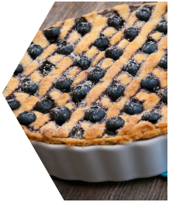
The Blueberry Pie

Community #7 (hereby referred to as "the community") was completely different… very different. From the very beginning, this community turned the “tour” into an “experience” that we had not encountered previously. They used atypical behaviors and actions, as well as team selling, to show that they were a different community who truly wanted my mom as a resident.


The appointment for the community was set for 1:00 PM on a Tuesday. Around 7pm the night before, my phone rang and I noted the caller ID had the community's sales director’s name, Kelly. Concerned that she was calling to cancel tomorrow’s appointment, I was
Atypical Action

surprised to find Kelly was instead calling to ask if she could "ask a few questions to prepare for my family’s ‘experience’ tomorrow?” Of course I said “yes” and for the next 5-7 minutes, answered Kelly's questions about my family, specifically my mom.

Now the appointment was set for 1:00 PM but we, like many of our customers, showed up early – thirty minutes early in fact. We immediately made note of two things: a large sign saying “WELCOME MARLOW FAMILY” written in calligraphy was posted just
outside the lobby and Kelly was waiting in the lobby to greet us by name--
even though we were thirty minutes early.


Atypical
Actions

&


Atypical Action

Once introductions were made and refreshments offered, Kelly escorted us to an office in a quiet place in the community. Notable for the lack of clutter and overall neatness,
a table had been set with nothing more than pens/pads for each for us.

Kelly’s first comment was, “Before we get started, I just want to share that we are in
this important decision making process together and regardless of whether you choose to live here or somewhere else, I am here to help you make the best decision for you, Mrs. Marlow.” This elicited the first of what was to be many smiles from my mom.

Kelly continued by asking us questions, and as a courtesy, began with my mom. Approximately five minutes into this “Discovery” session, there was a knock at the door. All eyes looked up to a very tall man in his chef’s whites and toque.
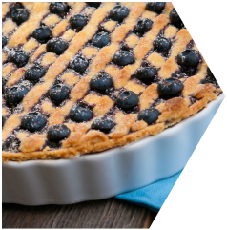
The Blueberry Pie

He stated, “You must be the Marlow family! And you must be Mrs. Marlow (looking at
my mom)?” “Yes I am Mrs. Marlow”, mom replied. “My name is Isaac and I am the executive chef here at the community. I heard through the grapevine that you love blueberry pie. Is that true?” Mom said, “I do love blueberry pie, Isaac; it is my favorite food in fact. How did you know?” Isaac responded, “As I said, I heard it through the grapevine or maybe it was a little birdy that told me (chuckling), I don’t remember exactly! However,
I did know that you were visiting today and I baked this blueberry pie this morning just

for you in honor of your visit today. Now, this is your first meal at our community and I
hope that it is the first of many meals I get to cook for you Mrs. Marlow. It would be my honor to do so. I will take this pie to the front desk so you don’t have to carry it around.
It was so nice to meet you all!”

My mom looked at me and asked, “How did he know that information about me?” I told her to just think of this place as Cheers, where everyone knew Norm’s name!” She liked that analogy very much. Another mom smile! Isaac’s “a little birdy told me” information actually came from Kelly who found out this story about my mom from her phone conversation with me the evening before.

Atypical
c

t
i
o
n

Kelly and I had agreed on the phone that this experience would last no more than one hour as we had another appointment later that afternoon. Of that hour, approximately 45 minutes was invested in the Discovery room and, it seemed, Kelly got to know my mom’s entire life story. Some of the questions were focused on my sister, and a few on me, but mom was definitely, and appropriately, the focus of Kelly’s questions.

The tour aspect of the experience was shorter than any of the rest of the appointments had been previously. The focus of the tour was completely aligned with what mom (and I) had shared with Kelly in the Discovery room.
Lasting approximately ten minutes, it was focused completely on the areas of interest “discovered.” This was, by far, the most customized tour we had experienced to date as most other locations showed much more (and sometimes ALL!) of the community than requested or necessary.


Atypical Action
Atypical Action
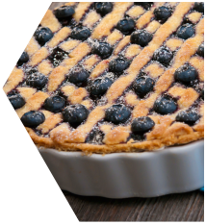
The Blueberry Pie
As we were preparing to depart and goodbyes were being shared, an employee appeared in the lobby, seemingly out of nowhere, exclaiming, “The Marlow family? Mrs. Marlow?” “Yes, we are the Marlows.” My mom quickly turned to me and quietly said, “I’m famous! Everyone already knows me here!”

“My name is Amy and I am the activities director here. I am so sorry that I have not been able to meet you before but I am so glad I caught you before you left. Mrs. Marlow, I heard a few things about you and because of what I know, I took the liberty of printing off next month’s activity calendar that I want to share with you. You will notice here on this first Tuesday, we have a hymn sing in our lobby. I know you love
to sing hymns so I put your name right there on that date. I will be glad to come to your apartment and accompany you to this event and I can introduce you to some of our regulars. I also put your name on both the Saturday and Sunday afternoon
church services we have at the community as I heard attending church is very
Atypical Action

important to you and I know you may not have a church to go to since you are new in town. I really hope you are living here with us by next month as I know you will love these activities and many more of the things we do around here. Please take this calendar with you and let me know if you have questions. It is so nice to meet you
and I look forward to seeing you again soon!” Amy’s action was also based on information from Kelly’s call the night before.

As we were leaving, Kelly looked at mom and shared, “I am so excited and appreciative that you are considering us, Mrs. Marlow. I want you to know that I really want you to live with us! But as I said earlier, I just want to help you make the best decision possible for you and your family. I know that if you do choose us, you will be such an asset to our community and hey, you already know several of our team members here and they know you! I also know that they share my enthusiasm for you becoming a part of our community’s family.”

l

As we walked out to the parking lot, I asked my mom what she thought of the community. Mom looked at me with some confusion. “What do you mean, what do I think?” I responded,
“I mean what do you think of this place, mom?” She said, “Well this is where I am going to live!” I was a bit surprised at the enthusiastic nature of her response but said, “I am more than good with you choosing this place, Mom!”

Later on that evening, I asked mom to go into more detail on her decision. “Why did you say ‘Well this is where I am going to live!’ in that community that we visited this afternoon? What caused you to decide that was the right place?” Mom shared “Wasn’t it obvious, Michael?
They wanted me more than the others did. Don’t you agree?” Through my tears, all I could say was “Yes, I do think that they want you more there, mom.”
t
p
c
A
t
o
n
i
c
a
i
y
A
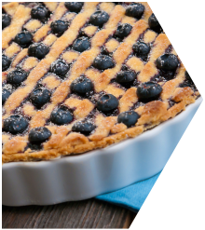
The Blueberry Pie
For the next three days, all three of us received hand-written thank you notes from EVERY department head at this community. These notes all had personal information included about my mom and each contained two very important words in each note. “I promise” was stated by each department head committing themselves to certain specific promises for my mom.

For example, Gladys, the Director of Housekeeping shared the following note:
Atypical Action



“Dear Mrs. Marlow, My name is Gladys and I am the Director of Housekeeping here at the community. I am so sorry that I missed you Tuesday when you visited. However, I wanted to let you know that I Promise to keep your apartment exactly as you like it once you live here with us. I hope that you will give me the opportunity to prove that to you as it would be an honor to have you as a part of the community family. Thank you and I look forward to meeting you soon! Gladys”

Mom moved into the community in November of 2015 and resides there to this day. She still refers to her “new” home as The Blueberry Pie Place and that is just fine with my sister and me. Even though the community has unfortunately experienced a great deal of employee turnover in the nearly four years since mom has been there, the commitment of the community to create a customized, unique experience every day for my mom and the other residents is still their greatest strength and greatest competitive advantage.

If you have questions about this story, or how to implement this experience-based sales philosophy into your community, please contact me for further details.

Michael Marlow

Vice President of Sales Education

