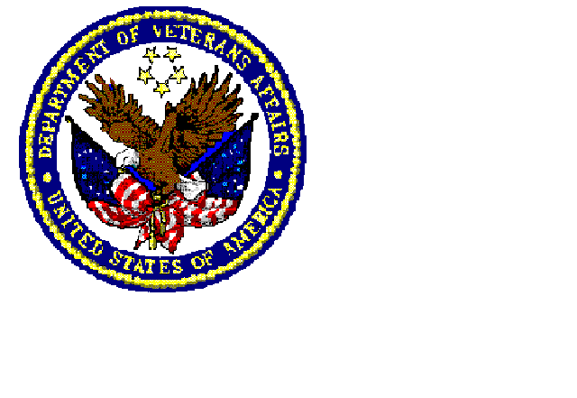VISN 23
VA Health Care System, Fargo, ND

Community Nursing Homes on Contract

NORTH DAKOTA City County
Ave Maria Village Jamestown Stutsman
Benedictine Living Center Garrison McLean
Bethany at 42nd Fargo Cass
Bethany on University Fargo Cass
Good Samaritan Center Lakota Nelson
Good Samaritan Center Larimore Grand Forks
Eventide Jamestown Stutsman
Luther Memorial Home Mayville Traill
Lutheran Sunset Grafton Walsh
Marian Manor Health Care Glen Ullin Morton
Maryhill Manor Enderlin Ransom
St. Catherine’s North Fargo Cass
St. Raphael Valley City Barnes
St. Rose Care Center LaMoure LaMoure
St. Luke’s Home Dickinson Stark
St. Catherine’s South Fargo Cass

MINNESOTA City County
Ecumen Nursing Home Detroit Lakes Becker
Good Samaritan Center Battle Lake Ottertail
Kittson, Memorial Healthcare Hallock Kittson
Mahnomen Health Center Mahnomen Mahnomen
Neilson Place Bemidji Beltrami
Northridge Residence Ortonville Big Stone
Perham Living Perham Ottertail
St. Mary's Nursing Center Detroit Lakes Becker
St. William’s Parkers Prairie Otter Tail
Villa St. Vincent Crookston Polk
Viking Manor Ulen Clay

South Dakota City County
Tekakwitha Sisseton Roberts

