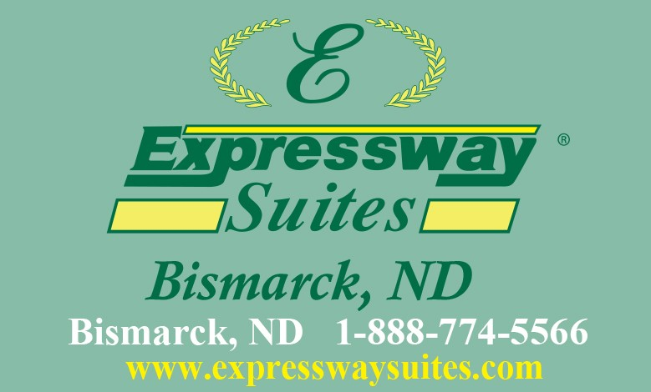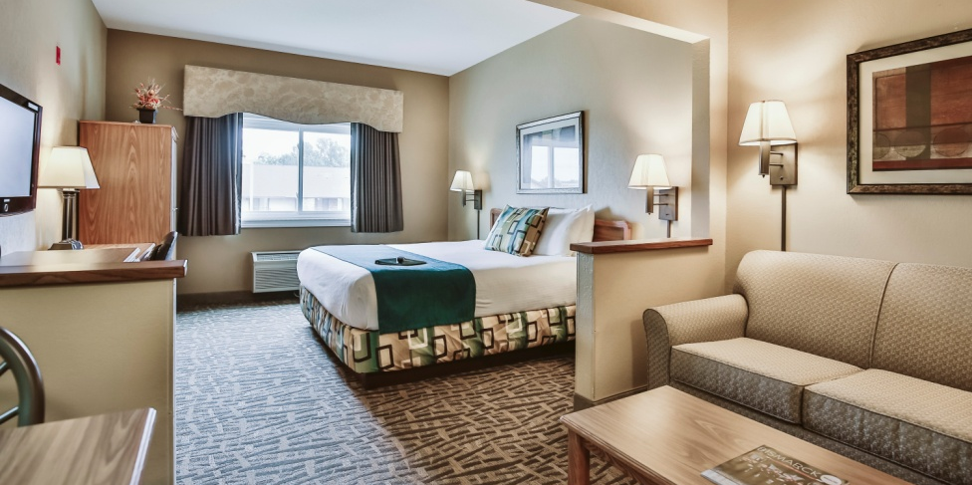

Welcome
ND Long Term Care Association Members
to the
Expressway Suites
-Free WIFI
-Free Breakfast
- All Rooms have Fridge & Microwave
-Indoor Pool, Hot tub & Exercise Room
- Courtesy Airport Shuttle
Expressway Suites
Expressway Lounge
& Casino
- 2 for 1 drink specials
Open Mon. – Sat. at 5pm

Monday - Thursday 5-8pm
-Free Nachos with your first drink
Friday & Saturday
- Free popcorn

2023 Rates
Double Queen or King Suite
Special Rate $99.95
All rates plus tax. No other discounts apply. Blackout dates may apply.
Not available during ND Long Term Care Annual Conference.

Ask for "ND Long Term Care" Rate!

701-222-3311 www.expresswaysuites.com
NEWLY RENOVATED LOBBY, LOUNGE & BREAKFAST AREA
