Aggressive Winter Storm
  - Situation Manual
December 14, 2021
This Situation Manual (SitMan) provides exercise participants with all the necessary tools for their roles in the exercise. Some exercise material is intended for the exclusive use of exercise planners, facilitators, and evaluators, but players may view other materials that are necessary to their performance. All exercise participants may view the SitMan.

Exercise Overview
Exercise Name | Winter Storm
Exercise Dates | December 14, 2021
Scope | This exercise is a Table Top Exercise planned for two hours in person and virtually at the Holiday Inn located at 3803 13th Ave S, Fargo ND 58103
Mission Area(s) | Response and Recovery
Core Capabilities | Logistics and Supply Chain Management  Operational Coordination  Public Information and Notification
Objectives | - Objective 1: Understanding and utilizing HAN Assets  - Objective 2: Exercise the use and understanding of HC Standard.  - Objective 3: Recognize concepts of Everbridge including Mass Notification, Emergency Alerts, and Routine Communication.
Threat or Hazard | Aggressive Winter Storm
Scenario | An aggressive winter storm has cut power to your facility. You will need to execute your emergency response plan to ensure your staff and residents are properly taken care of. Having knowledge of (or learning) HC Standard, HAN Assets, and Everbridge will help your success in this scenario.
Sponsor | Fargo Cass Public Health
Participating Organizations | Fargo Cass Public Health  North Dakota Department of Health  North Dakota Long Term Care Association  Central Valley Health District
Point of Contact | Doug Murphy  Emergency Preparedness and Response Coordinator  Fargo Cass Public Health  701-476-4066  DMurphy@FargoND.gov

General Information

Exercise Objectives and Core Capabilities
The following exercise objectives in Table 1 describe the expected outcomes for the exercise. The objectives are linked to core capabilities, which are distinct critical elements necessary to achieve the specific mission area(s). The objectives and aligned core capabilities are guided by elected and appointed officials and selected by the Exercise Planning Team.
Exercise Objective | Core Capability
Understanding and utilizing HAN Assets | Logistics and Supply Chain Management
Exercise the use and understanding of HC Standard. | Operational Coordination
Recognize concepts of Everbridge including Mass Notification, Emergency Alerts, and Routine Communication. | Public Information and Notification

Table 1. Exercise Objectives and Associated Core Capabilities

Exercise Design Objectives Detail
Exercise design objectives focus on improving understanding of a response concept, identifying opportunities for improvement or problems, and achieving a change in attitude. This exercise will focus on the following design objectives selected by the Exercise Planning Team:
- Understanding and utilizing HAN Assets. Identify HAN Assets and all that it encompasses in regards to Logistic and Supply Chain Management. Identify how HAN Assets can be an asset to your facility and assist you in emergency scenarios. Demonstrate how to access HAN Assets when needed. Identify a person or persons who can comfortably operate HAN Assets for your facility.
- Exercise the use and understanding of HC Standard. Understand HC Standard capabilities and identify situations for its use. Identify individuals within the facility that have an understanding of HC Standard’s operability.
- Recognize concepts of Everbridge including Mass Notification, Emergency Alerts, and Routine Communication. Identify how to access mass notification, emergency alerts, and routine communication effectively and efficiently for your facility including communication to staff and next of kin. Understand how Everbridge works, and identify a person or persons who can comfortably request messaging for you facility.

Participant Roles and Responsibilities
The term participant encompasses many groups of people, not just those playing in the exercise. Groups of participants involved in the exercise, and their respective roles and responsibilities, are as follows:
Players. Players are personnel who have an active role in discussing or performing their regular roles and responsibilities during the exercise. Players discuss or initiate actions in response to the simulated emergency.
Observers. Observers do not directly participate in the exercise. However, they may support the development of player responses to the situation during the discussion by asking relevant questions or providing subject matter expertise.
Facilitators. Facilitators provide situation updates and moderate discussions. They also provide additional information or resolve questions as required. Key Exercise Planning Team members also may assist with facilitation as subject matter experts (SMEs) during the exercise.
Evaluators. Evaluators are assigned to observe and document certain objectives during the exercise. Their primary role is to document player discussions, including how and if those discussions conform to plans, polices, and procedures.

Exercise Structure
This tabletop exercise will be a multimedia, facilitated exercise. Players will participate in the following four modules:
Module 1: Aggressive Winter Storm Potential Outlook – Five Days Out (HAN Assets)
Module 2: Aggressive Winter Storm Potential Outlook – Three Days Out (Everbridge)
Module 3: Aggressive Winter Storm Event Response Readiness (HC Standard)

Each module begins with a multimedia update that summarizes key events occurring within that time period. After the updates, participants review the situation and engage in group discussions of appropriate response issues.
After these group discussions, participants will engage in a facilitated discussion in which a spokesperson will present a synopsis of the group’s actions, based on the scenario.

Exercise Guidelines
This tabletop exercise will be held in an open, low-stress, no-fault environment. Varying viewpoints, even disagreements, are expected.
Respond based on your knowledge of current plans and capabilities (i.e., you may use only existing assets) and insights derived from your training.
Decisions are not precedent setting and may not reflect your organization’s final position on a given issue. This exercise is an opportunity to discuss and present multiple options and possible solutions.
Issue identification is not as valuable as suggestions and recommended actions that could improve response and preparedness efforts. Problem-solving efforts should be the focus.

Assumptions and Artificialities
In any exercise, assumptions and artificialities may be necessary to complete play in the time allotted. During this exercise, the following apply:
- The scenario is plausible and events occur as they are presented.
- There is no hidden agenda, and there are no trick questions.
- All players receive information at the same time.

Exercise Evaluation
Evaluation of the exercise is based on the exercise objectives and aligned capabilities, capability targets, and critical tasks, which are documented in Exercise Evaluation Guides (EEGs). Evaluators have EEGs for each of their assigned areas. Additionally, players will be asked to complete participant feedback forms. These documents, coupled with facilitator observations and notes, will be used to evaluate the exercise and compile the After-Action Report (AAR).

Module 1: Aggressive Winter Storm Potential Outlook – Five Days Out

Tuesday December 14, 2021: 1000 hours
Although it feels like a normal week, the brutal winter months of North Dakota are starting to settle in. You plan to have a family day Christmas celebration at your facility on Saturday between 10 am and 2 pm. You watched the morning news on TV this morning and heard that there could be severe winter storm this weekend. You decide to go over to your local weather website to see what they have to say about the forecast.
Being the proactive person you are, you decide to start getting ready for the worst possible outcome and start evacuation planning. After completing an inventory of the supplies and equipment that you have on hand, you realize that you are missing some items or simply do not have them.

Questions
Based on the information provided, participate in the discussion concerning the issues raised in Module 1. Please identify any additional requirements, critical issues, decisions, or questions that should be addressed at this time.
The following questions are provided as suggested general subjects that you may wish to address as the discussion progresses. These questions are not meant to constitute a definitive list of concerns to be addressed.
- Were you aware of the HAN Assets before this exercise? If so, how often do you view this product and have you seen what resources your facility could use?
- Have you ever had to utilize HAN Assets before?
- How often do you take an inventory of your equipment that would be used in times of an emergency?
- How often do you prepare for the worst possible outcome when there are blizzard warnings?
- Do you conduct weekly, monthly, quarterly maintenance on your equipment? What is your current maintenance schedule?

Module 2: Aggressive Winter Storm Potential Outlook – Three Days Out

Thursday December 16, 2021: 0800 hours
You arrive in your office on Thursday morning. You remember that there was a possibility of a snow storm this weekend and decide to look at the forecast.

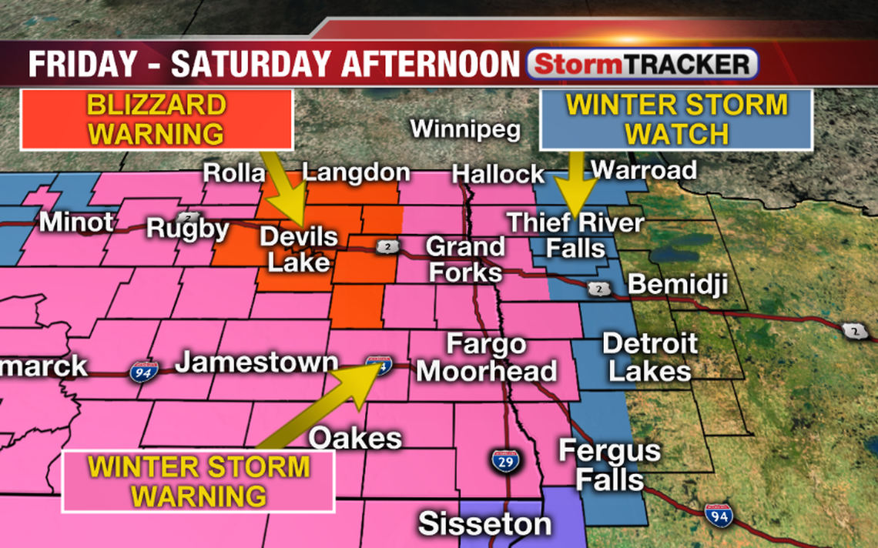

Thursday December 16, 2021: 1400 hours
You return to your office after lunch and decide to tune into the weather station for an update on the upcoming storm. The weather station is now saying that there is a severe blizzard warning now or as they call it an “Aggressive Winter Storm.” With the upcoming blizzard, you decide that it is a risk for family members to be on the road and run the risk of them getting stuck or worse and cancel the Christmas celebration at your facility.

Questions
Based on the information provided, participate in the discussion concerning the issues raised in Module 2. Please identify any additional requirements, critical issues, decisions, or questions that should be addressed at this time.
The following questions are provided as suggested general subjects that you may wish to address as the discussion progresses. These questions are not meant to constitute a definitive list of concerns to be addressed.
- Have you utilized the program Everbridge before? If so, when was the last time you had submitted a list or a message to be pushed out?
- How often do you update your staff, resident, and NOK lists? Do you update these internally or do you send out the updated lists for us to enter into Everbridge?
- On a scale of 1-10 how comfortable are you with basic Microsoft Xcel skills and tasks?

Module 3: Impending Aggressive Winter Storm Event Response Readiness
Saturday December 18, 2021: 1300 hours
It has been snowing all morning, NDDOT has closed off all highways due to large amounts of snowfall and high winds creating snow drifts.
As you are sitting at your desk you see the lights start to flicker a little bit, after a few minutes the power goes out completely
Saturday December 18, 2021: 1400 hours
After rushing to get power back up from the generators that you had acquired from LPH and HAN Assets half of the generators go out, leaving you without power again.
Saturday December 18, 2021: 1415 hours
Luckily, an employee knows a thing or two about generators and looks at them. They inform you that they are unable to get them running again. Now half of your patients do not have any power and are starting to panic and become quit cold.
Questions
Based on the information provided, participate in the discussion concerning the issues raised in Module 3. Please identify any additional requirements, critical issues, decisions, or questions that should be addressed at this time.
The following questions are provided as suggested general subjects that you may wish to address as the discussion progresses. These questions are not meant to constitute a definitive list of concerns to be addressed.
- How many people would you estimate would be required to facilitate the safe evacuation for your entire facility?
- What facility(s) will your residents go to? Who determines this? If your facility is not affected, would your facility be able to take in evacuated residents?
- Do you have polices in place to request additional facility healthcare workers to assist your residents during an emergency event? How long would it take these individuals to respond? Have you ever drilled/exercised this policy
- Who is responsible for identification and tracking of residents during the evacuation process? How would this be coordinated?
- How would you compensate and adjust for loss of revenue during the event? Does your emergency management plan define an individual who would keep track of reimbursements? How are the financial aspects of resident care handled with the receiving facilities?

Appendix A: Exercise Schedule
Note: Because this information is updated throughout the exercise planning process, appendices may be developed as stand-alone documents rather than part of the SitMan.
Time | Activity
October 16, 2018
8:00am | Exercise Overview, Expectations and Objectives
8:15am | Module 1: Briefing / Caucus Discussion
8:30am | Module 1: Report-Out
8:45am | Module 2: Briefing / Caucus Discussion
9:00am | Module 2: Report-Out
9:15am | Module 3: Briefing / Caucus Discussion
9:30am | Module 3: Report-Out
9:45am | EndEx / Hotwash

Appendix C: Acronyms
Acronym | Term
AAR | After-Action Report
LPH | Local Public Health
HAN Assets | Health Alert Network Assets
SitMan | Situation Manual

Notes

Responses to Annual Exercise

- Regarding the possible evacuation of your facility: How will you notify your residents’ next of kin (NOK)? If you do not have your NOK list in a mass notification system (ex. Everbridge), have you tested it? Was it successful? How long did it take to complete the notification? If you do have your staff and NOK in a mass notification system, do you send quarterly, annually tests? (If you have your staff and NOK in Everbridge, I can assist you in setting up your scheduled tests.)

- Regarding the evacuation process: Do you have multiple levels or floors in your facility? How will you evacuate the residents who are not on ground level? Have you tested this process? How well did it work? Have you considered ordering stretchers from HAN Assets to train for this process? Many times what seems like a good plan on paper turns out to be a disaster when exercised.

- Regarding the evacuation process: Does your facility have Evacuation Tags? If not, order them from HAN Assets. http://hanassets.nd.gov/tag-triage-nursing-facility-evacuation-su-cs-iu-pkg-25-ea-pkg.html There is no cost to you.

- Familiarize your management team with HAN Assets. Go to hanassets.nd.gov and order the ‘test’ item. You should receive a phone call or email from NDDoH confirming your order.

- How will you incorporate the lessons learned in today’s exercise into your emergency operations plans?

